PostgreSQL 18 Deployment on Kubernetes (Minikube)

This project demonstrates a simple Proof-of-Concept deployment of PostgreSQL 18 on Kubernetes using Minikube.

The objective of this lab is to help DBAs understand:
- Running PostgreSQL inside containers
- Kubernetes Stateful workloads
- Persistent storage for databases
- Pod restart and data persistence validation

Architecture
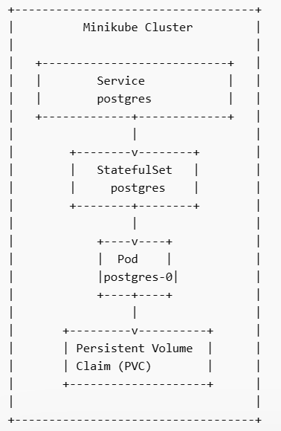

Environment
Component | Version
OS | Linux / Ubuntu
Kubernetes | Minikube
PostgreSQL | 18
Container Runtime | Docker

1 Install kubectl
curl -LO https://storage.googleapis.com/kubernetes-release/release/$(curl -s https://storage.googleapis.com/kubernetes-release/release/stable.txt)/bin/linux/amd64/kubectl

chmod +x kubectl
sudo mv kubectl /usr/local/bin/

Verify
kubectl version --client

2 Install Minikube
curl -LO https://storage.googleapis.com/minikube/releases/latest/minikube-linux-amd64

chmod +x minikube-linux-amd64
sudo mv minikube-linux-amd64 /usr/local/bin/minikube

Verify
minikube version

3 Start Kubernetes Cluster
minikube start
Check cluster
kubectl get nodes

Expected output
NAME STATUS ROLES
minikube Ready control-plane

4 Create PostgreSQL Deployment File
Create file
nano postgres-k8s.yaml
Paste configuration

apiVersion: v1
kind: Service
metadata:
name: postgres
spec:
ports:
- port: 5432
clusterIP: None
selector:
app: postgres

---
apiVersion: apps/v1
kind: StatefulSet
metadata:
name: postgres
spec:
serviceName: postgres
replicas: 1
selector:
matchLabels:
app: postgres

template:
metadata:
labels:
app: postgres
spec:
containers:
- name: postgres
image: postgres:18
ports:
- containerPort: 5432

env:
- name: POSTGRES_USER
value: postgres
- name: POSTGRES_PASSWORD
value: secret
- name: POSTGRES_DB
value: testdb

volumeMounts:
- name: postgres-storage
mountPath: /var/lib/postgresql

volumeClaimTemplates:
- metadata:
name: postgres-storage
spec:
accessModes: ["ReadWriteOnce"]
resources:
requests:
storage: 1Gi

5 Deploy PostgreSQL
kubectl apply -f postgres-k8s.yaml

Expected
service/postgres created
statefulset.apps/postgres created

6 Verify Deployment
Check pod
kubectl get pods

Expected
postgres-0 1/1 Running

Check storage
kubectl get pvc

Example
postgres-storage-postgres-0 Bound 1Gi

7 Check PostgreSQL Logs
kubectl logs postgres-0

Expected
database system is ready to accept connections

8 Connect to PostgreSQL

kubectl exec -it postgres-0 – psql -U postgres -d testdb

Check version
select version();

Expected
PostgreSQL 18.x

9 Verify Database Storage Path
Enter container
kubectl exec -it postgres-0 – bash

Navigate to data directory
cd /var/lib/postgresql/18/docker

List files
ls
Typical PostgreSQL directories
base
global
pg_wal
pg_stat
pg_xact
PG_VERSION

Exit container
exit

10 Test Persistent Storage
Connect again
kubectl exec -it postgres-0 -- psql -U postgres -d testdb

Create table
CREATE TABLE k8s_test(id INT, name TEXT);

INSERT INTO k8s_test VALUES
(1,'PostgreSQL'),
(2,'Kubernetes'),
(3,'Minikube');

SELECT * FROM k8s_test;

Restart Pod
kubectl delete pod postgres-0

Kubernetes automatically recreates the pod.

Check again
kubectl get pods
Reconnect to PostgreSQL and verify data still exists.
This confirms Persistent Volume storage works correctly.

Kubernetes Objects Used
Object | Purpose
Service | Internal cluster networking
StatefulSet | Stateful application management
Pod | Runs PostgreSQL container
PVC | Persistent storage for database
PV | Physical storage resource

Key Learning Points
- PostgreSQL runs inside a container managed by Kubernetes
- StatefulSet provides stable identity and storage
- Persistent Volumes protect database data
- Kubernetes automatically recreates failed pods

